The Book of Daniel

An Expositional Study

**Dr. Todd A. Dykstra**

**The Expositors Seminary**

**Maranatha Bible Church (Grand Rapids)**

# Part 1 – Introduction to Daniel

## Title

In both the Hebrew and Greek canons, the book is titled, not primarily from its contents, but after its main character and likely author. Daniel’s name means “God is My Judge.” Throughout the book, Daniel received numerous visions from God and served as God’s mouthpiece to both the Jewish and Gentile worlds. With its emphasis on prophecy and God’s plan for the future, Daniel functions as the “Revelation” of the Old Testament.

## Historical Background

1. Context

The time of Israel’s monarchy began in about 1050 BC with Israel’s first king, Saul, a giant of a man but with a very small heart for God. After his 40-year rule, God gave Israel a king after His own heart, David, who reigned over the united kingdom for 40 years (1010-970 BC). Following David’s rule, his son, Solomon, ascended the throne and reigned over Israel for 40 years (970-930 BC). Despite his wisdom, Solomon’s heart turned from God and the nation was split in two immediately upon his death, divided into a northern and southern kingdom in 930 BC. The northern kingdom, comprised of 10 tribes of Israel, had no godly kings. All 19 kings were evil, disobeying God’s commands and committing idolatry. As a result, after hundreds of years of patience and numerous warnings by prophets, God took the 10 northern tribes of Israel captive to Assyria in 722 BC, 208 years after the kingdom was divided in 930 BC (see 2 Kings 17).

The southern kingdom (comprised of Judah and Benjamin) remained in the land for another roughly 120 years. Of the 20 kings who reigned over the southern kingdom, only eight were godly men. Years before, Isaiah and other faithful prophets of God had sounded the alarm that Judah’s continual sin without national repentance would eventually lead to God’s judgment. Even during that time, prophets like Jeremiah, Joel, Micah, Habakkuk, and Zephaniah pleaded with and warned Judah that if they didn’t repent and turn back to the Lord, they too would be taken captive like the northern kingdom. Such occurred in 605 BC at the hands of Nebuchadnezzar who rose to power when the Assyrians’ grip on the region loosened.

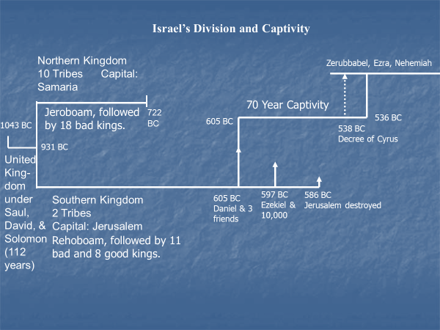

1. Summary of Babylon’s History

* Despite their domination for centuries, Assyria was on the brink of collapse due to the rise of Babylon’s power
* In October 626 BC, the Chaldean prince Nabopolassar (Nebuchadnezzar’s father) defeated the Assyrian army outside of Babylon and claimed the throne in a coup
* Nabopolassar consolidated his empire and by 616 BC he was on the march to expand his territory
* He destroyed Nineveh, the capital of Assyria in 612 BC (as Nahum prophesied)
* During this same time, Egypt sensed an opportunity to expand their territory in light of Assyria’s collapse
* If a weakened Assyria could be maintained as a buffer state to halt Babylon’s westward advance, Egypt would be free to reclaim much of western Palestine (including Judah) which they had lost to Assyria earlier
* Thus, in 609 BC, Pharoah Neco marched with a large Egyptian army toward Haran to support the remaining Assyrian forces in a last attempt to retake their lost territory
* Josiah, king of Judah, knew what the consequences would be for Judah if Egypt were successful…he did not want Egypt to replace Assyria as Judah’s taskmaster
* So, Josiah tried to prevent the Egyptians from joining Assyria and mobilized his army to stop the Egyptian advance
* A battle took place on the plain of Megiddo and Judah lost; Josiah was killed in the battle and the Egyptian army continued on toward Haran (2 Kings 23:28-30)
* After the defeat of Judah, Egypt assumed control of Palestine
* Judah had appointed Jehoahaz king in place of his father Josiah but after a reign of only 3 months he was deposed by Pharoah Neco and taken to Egypt
* Neco then plundered the treasuries of Judah and appointed Jehoiakim, another son of Josiah, as a vassal king in Palestine (2 Kings 23:34-35), the same Jehoiakim mentioned in Dan 1:1
* From 609-605 BC, the Egyptians/Assyrians and Babylonians faced each other at Carchemish (on the west bank of the Euphrates river) with neither side able to gain the upper hand
* But in 605 BC, the crown prince of Babylon, Nebuchadnezzar, led the Babylonian forces to a decisive victory in one of the greatest battles in the history of the world, soundly defeating the Egyptians and Assyrians
* Nebuchadnezzar won a great victory at the Battle of Carchemish and was about to invade Egypt itself when he received news of his father’s death
* He returned to Babylon in August 605 BC to take the throne of his father Nabopolassar
* But he returned to Palestine and attacked Jerusalem in September 605 BC, solidifying his rule over Judah by conquering Jerusalem and appointing kings and taking hostages to assure continued loyalty to him
* Daniel 1:1-2 describes this event (cf. 2 Kings 24:1-5)
* When Nebuchadnezzar invaded Judah, he took sacred vessels from the house of God and carried them back to the temple of the Babylonian god, Bel-Merodach, in Babylon
* It was typical in that day for a conquering king to bring back the artifacts of worship from another country to “prove” the impotence of its gods
* This set up the three deportations of Jews from Israel to Babylon:
  + First deportation (605 BC) – Nebuchadnezzar took the finest youth to train them in his court, possibly to prepare them for positions of administrative leadership there if Nebuchadnezzar should have to return to subjugate Judah
  + Second deportation (597 BC) – Jehoiakim was followed on the throne by his son, Jehoiachin (cf. 2 Kings 24:6-20) whom Nebuchadnezzar deported along with another 10,000 Jewish people, including leaders, skilled laborers, and soldiers, including Ezekiel
  + Third deportation (586 BC) – Nebuchadnezzar chose Jehoiachin’s uncle, Zedekiah, to serve as Judah’s vassal king but his 11-year reign (597-586 BC) was marred by spiritual decline and political instability. Rather than learning from the mistakes of the past, Zedekiah repeated them and tried to rebel against Babylon’s control. Nebuchadnezzar’s response was swift and harsh as he determined to put an end to rebellious Judah. The army of Babylon surrounded Jerusalem and began a 2-year long siege. In August 586 BC, the city fell and was totally destroyed, along with Solomon’s temple (cf. 2 Kings 25:1-17). The Jews who were not killed in this assault were deported to Babylon.

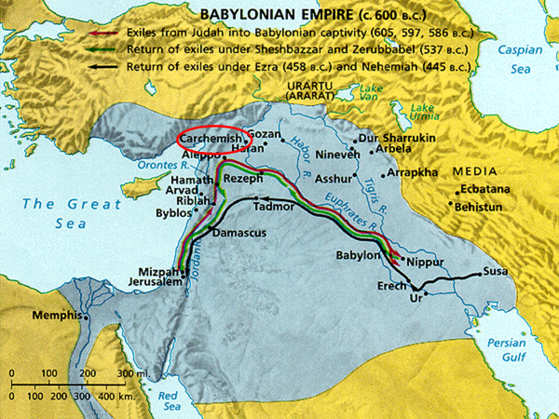

* Judah remained exiled in Babylon for 70 years (as prophesied in Jeremiah 25:11-12; 29:10) until about 536 BC, when they were released from captivity after the Medo-Persians conquered Babylon in 539 BC.

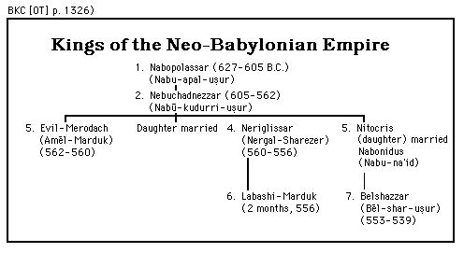

1. Daniel in Babylon

Daniel and his three friends were taken captive in the first group of deportees in 605 BC and Ezekiel soon followed in the second wave in 597 BC. Likely kidnapped at about age 15, Daniel was forced into service of the king and brainwashed into Babylonian culture for the purpose of overseeing the Jews who had been imported from Judah. Thus, Daniel spent the bulk of his life as a captive in Babylon, likely living to 85 years old or older in a foreign land. He served in the king’s court in Babylon until the Babylonians were conquered by Cyrus of Persia in 539 BC and a few years into the Medo-Persian rule (Dan 10:1).

It was during this time that Daniel received revelation from God concerning the stages of Gentile world domination: Babylon, Medo-Persia, Greece, and the Roman Empire. These four great empires are in view in Daniel’s prophecies, especially detailed in chapters 2, 7, 8, and 11. As Jewish desolation was occurring and Gentile domination was beginning, God provided a panoramic picture of the whole period of Gentile lordship, the time during which Gentiles would exercise power and authority over the Jewish people. However, Daniel also foresees a time when the greatest Conqueror, the Messiah, would put down all Gentiles rulers and nations, would defeat all His foes, and would work Jewish deliverance by establishing His glorious, millennial, earthly kingdom.

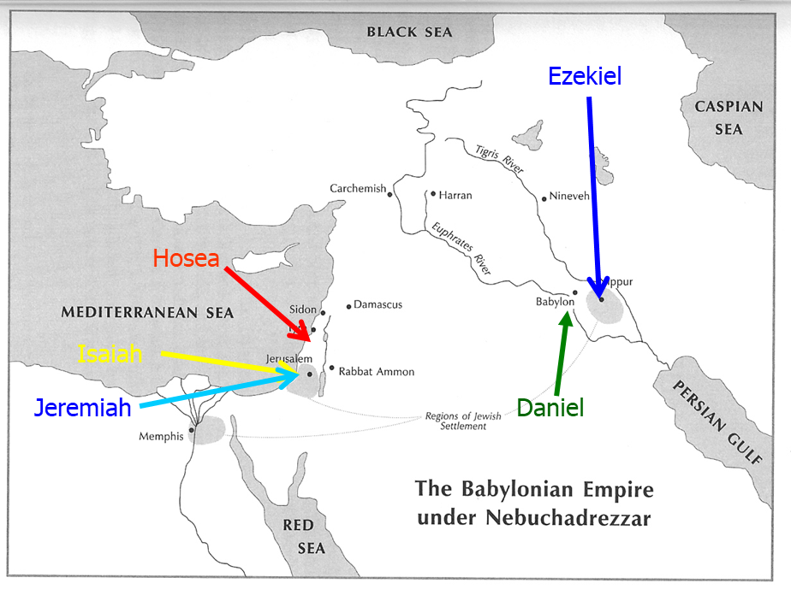

701

Jerusalem

Spared

605

First

Deportation

597

Second

Deportation

586

Fall of

Judah

722

Fall of

Israel

536

Construction of temple

begun

## Author

Little is known of Daniel’s family background other than that he was born into the royal family and was of noble birth (Dan 1:3, 6). He was physically attractive and mentally sharp (Dan 1:4). He was kidnapped from his family in Judah as a teenager (“youth” in Dan 1:4) and transported to Babylon where he spent the rest of his life, living a life of integrity and serving as a prophet and counselor to kings in two world empires: the Babylonians (Dan 2:48) and the Medo-Persians (Dan 6:1, 2).

Though his parents are not named, they must have done an outstanding job in inculcating faith and devotion to God in their son.

Daniel was one of those rare individuals in Scripture about which nothing negative is recorded. In fact, he had an outstanding reputation among his contemporaries for righteousness and devotion to God. From the testimony of his contemporaries, he was known for his righteousness (Ezek 14:14, 20) and his wisdom (Ezek 28:3).

He is mentioned in these passages with Noah and Job, who were historical people, so Daniel was also a historical person, not a fictional character. Jesus affirmed that it was Daniel the prophet who spoke of the “abomination of desolation” (Matt 24:15). Four important truths about Daniel arise from Christ’s statement:[1]

1. First, Christ demonstrated his belief that Daniel was a real, historical person who was an instrument of divine revelation.
2. Second, Christ held that the prophecies contained int eh book of Daniel (from which he quoted) came from Daniel himself, not a later anonymous individual
3. Third, Christ assured that this prophecy describes future events, for the context shows that “the abomination that causes desolation” to which Christ referred was yet future.
4. Fourth, apparently the only view in vogue during the time of Christ for the setting of the prophet Daniel was the sixth century BC; therefore if Christ treated Daniel as a historical individual, he also assumed the sixth-century date.

Daniel is also alluded to by the writer of Hebrews as one of “the prophets, who by faith…shut the mouths of lions” (Heb 11:32, 33).

This book has been under more critical attack than almost any other OT book regarding authorship. Critics who do not accept prophecy as a supernatural predictive reality have sought to assign a late date to the book, usually in the time of Antiochus Epiphanes, king of Syria (175-164 BC). However, conservative scholars argue for a sixth century authorship by Daniel (see below on Date)

Porphyry (232-303 AD) was the first to reject Danielic authorship on the basis that there could be no predictive element in prophecy. Since then, many other critics have assigned a late date to the book.

“[In] the case of Daniel strong internal and external evidence exists to support his authorship of the book. Internally the employment of the first-person pronoun occurs in contexts that strong imply authorship (Dan 7:15; 8:1-8; 9:2, 22; 10:2, 7, 10, 12, 15, 18-19; 11:1; 12:5-8). Externally the vigorous attack against Danielic authorship by the Neo-Platonic philosophy Porphyry (third century AD) presupposes a well-nigh universal consensus that Daniel wrote the book. The supreme example of such a presupposition is the testimony of Jesus, who clearly held to Daniel’s authorship of the book that bear his name (Matt 24:15). Only a revision of the date of the composition of Daniel based on considerations other than the testimony of the book itself can divest it of its traditional ascription to Daniel of the sixth century BC.”[2]

Further external evidence of Danielic authorship comes from the fact that the writer shows an accurate knowledge of 6th century events such as:

1. The city of Susa is described as being in the province of Elam back in the time of the Chaldeans (8:2)
2. In chapter 9, the writer goes beyond the Maccabean period by predicting the crucifixion of Christ and the following destruction of the city of Jerusalem

## Date

The events of the book of Daniel span the period from 605 BC (Dan 1:1) to 536 BC (Dan 10:1)

Likely, Daniel wrote the book shortly after 536 BC (Dan 10:1) but before 530 BC, the date of the death of Cyrus, the last ruler mentioned by name (Dan 6:28).

While many conservative scholars agree with a sixth century authorship (Walvoord, Wood, EBC, BKC, Miller, Whitcomb), many other scholars argue for a late date around 165-150 BC (Goldingay, Lucas). This is because “the portions that allege to be predictive prophecies are so accurate in their fulfillment that scholars who on whatever grounds are unprepared to concede the possibility of prediction-fulfillment have no recourse but to view such texts as *vaticinia ex eventu*, that is, ‘predictions’ after the fact. This obviously vitiates the historical Daniel’s authorship of much of the book and requires both anonymity of authorship and dates of composition much later than the sixth century, in some cases no earlier then around 164 BC.”[3]

“The great majority of critics regard this book as entirely spurious and composed centuries after the death of the sixth-century Daniel. They understand it to be a work of historical fiction composed about 167 BC and intended to encourage the resistance movement against the tyranny of Antiochus Epiphanes.”[4]

As a result, a number of critics deny the historical existence of Daniel and instead view him as a legendary figure. They view the book of Daniel as written during the 2nd century BC by an anonymous Jew writing under the pseudonym Daniel.

If correct, this would make Daniel the latest book in the Old Testament canon.

However, there is no good reason for accepting Daniel as a Maccabean pseudepigraph (i.e. as a prophecy written after the event); rather, it should be accepted as a collection of Daniel’s memoirs written in final form at the end of his career in Babylon in the 6th century BC. Thus, the “Maccabean thesis” should be rejected.

A summary of the objections (with responses) to an early Danielic authorship are as follows:

1. The Placement of Daniel in the *Kethubim*
2. Argument

In the English Bible, Daniel is placed as the last of the four major prophets. However, the fact that Daniel was placed in the third part of the Hebrew canon (*Kethubim, Hagiographa,* The Writings), rather than among the prophets, argues for its lateness. This must mean that the book was written later than all the prophets since the books in the Writings were written after the prophetic books were written.

1. Response

The presence of a book in the Writings does not necessarily argue for a late date since a number of books in the Writings are earlier than or contemporary with Daniel (i.e. Job, the Davidic Psalms, the writings of Solomon). Daniel appears in the *Kethubim* not because of a late date but because early Jewish tradition regarded Daniel as a statesmen with the gift of prophecy rather than as a prophet. He was not technically a prophet like Isaiah or Jeremiah who acted as prophets in Israel to the Jewish people.

1. The Failure of Ben Sirach to Mention Daniel
2. Argument

Jesus Ben Sirach, author of the Apocryphal book Ecclesiasticus (180 BC), makes no mention of Daniel despite mentioning all the other prophets (the Minor Prophets mentioned collectively).

1. Response

Other key figures such as Ezra, Job, all the judges, and Mordecai also receive no mention by him yet were undisputable historical figures. “Lack of reference hardly constitutes proof of nonexistence”[5] as it is an argument from silence.

1. The Presence of “Historical Inaccuracies”
2. Argument

Supposed historical inaccuracies in the book argue that the author likely lived much later than the events he wrote about and was, therefore, too far removed from the events to be precise in his details. For example, Daniel 1:1 describes Nebuchadnezzar’s invasion of Judah as taking place in the third year of Jehoiakim’s reign; however, Jeremiah 46:2 dates it in his fourth year.

1. Response

Understanding the difference between the Jewish practice of time (non-accession year chronology) and the Babylonian practice of time (accession year chronology) accounts for this discrepancy. Furthermore, the author of Daniel demonstrated an extensive knowledge of 6th century BC historical events, more so than would be understood by a 2nd century BC author. In other words, the author included a number of amazing historical details, something only someone present would likely have understood and reported.

1. The Use of the Term *kasdim* (Chaldeans)
2. Argument

This term refers to one class of wise men in the book of Daniel (2:5, 10; 4:7; 5:7, 11, 30), a term critics argue could not have become specialized enough to indicate this class until a much later time. They assume that this ethnic term would not have been used until after the Babylonian empire had collapsed and were nearly forgotten.

1. Response

The same term is used in Daniel 5:30 in reference to Belshazzar, the king. Thus, the term in Daniel referred to both a specific race of people in general and a special class of wise men within the ethnic Babylonians. The theory of a late date for Daniel misses the two-fold use of this term. Further, Herodotus used the term to refer to the priests of Bel in Babylon as early as the 5th century.

1. The Mention of Darius the Mede
2. Argument

“Who was this ruler? Negative biblical scholarship of our day insists that he was a mere figment of imagination, concocted out of a conglomeration of historical errors in the mind of an unknown writer in in the second century BC.”[6] He must be a fictitious figure since no historical evidence outside the Bible exists for the reign of one named Darius the Mede.

1. Response

Numerous reasonable solutions to the problem of his identification have been offered including: 1) Darius was another name for Gubaru, the man whom Cyrus made to be governor over all of Babylonia; 2) Darius was another name for Ugbaru, a general who captured Babylon for Cyrus but who died soon after; 3) This is another name for Cyrus the Persian himself since the term “Darius” could serve as a title and it was common for ancient rulers to use different names in various parts of their realms.

1. The Presence of Persian and Greek Loan Words
2. Argument

“It has been alleged that the numerous foreign words in the Aramaic portion of Daniel… conclusively demonstrate an origin much later than the sixth century BC. There are no less than fifteen words of probable Persian origin…and their presence proves quite conclusively that even the chapters dating back to Nebuchadnezzar and Belshazzar could not have been composed in the Chaldean period.”[7]

Also, the presence of three Greek loan words (all referring to musical instruments) appearing in the Aramaic portion of the book (3:5, 7, 10 15) constitute proof of a late date since they could not have been available to Daniel until the spread of Greek culture under Alexander the Great.

1. Response

“This contention may be freely admitted, but conservative scholars do not maintain that the book of Daniel was composed, in its final form at least, until the establishment of the Persian authority over Babylonia. Since the text indicates that Daniel himself lived to serve, for several years at least, under Persian rule, there is no particular reason why he should not have employed in his language those Persian terms (largely referring to government and administration) which had found currency in the Aramaic spoken in Babylon by 530 BC.”[8] In other words, since the Persian period began in 539 BC and Daniel likely wrote the book shortly after 536 BC (Dan 10:1) but before 530 BC, one would expect Persian words.

Regarding the Greek loan words, some were utilized in other literature (i.e. Homer in the 8th century BC) indicating they were likely available to Daniel in the 6th century BC. Additionally, “recent archaeological evidence has demonstrated that the whole argument based upon the premise that Greek loan words could not have been found in Near Eastern literature before the time of Alexander the Great is flawed”[9] since Greek trading extended into this region from at least the early 7th century BC. Finally, “the meager number of Greek terms in the Book of Daniel is a most convincing argument that the prophecy was not produced in the Maccabean period, the heart of the Greek era”[10] since a large number of Greek terms would be present in a work produced in this period.

1. The Aramaic of Daniel
2. Argument

The Aramaic of Daniel is thought to be of a Western dialect and, therefore, could not have been composed in Babylon, as would be true if Daniel really wrote the book in the 6th century BC. The Aramaic section of Daniel rightly belongs to the 2nd century BC.

1. Response

Most linguists now believe that the Aramaic in Daniel is of an Imperial dialect (like Ezra) which was used no later than the 5th century BC. “Moreover, the Aramaic of Daniel and Ezra exhibits striking parallels with early examples of the language found in such documents as the Elephantine Papyri, also written in Imperial Aramaic and dated to the fifth century BC.”[11] Thus, it seems apparent that the Aramaic portion of Daniel comes from a time substantially earlier than the 2nd century BC.

1. The Theological Emphases in Daniel
2. Argument

Theological motifs in Daniel which resemble those characterizing the apocryphal literature of the Intertestamental Period argue for a late date. “These emphases include the prominence of angels, the stress upon the last judgment, the resurrection of the dead, and the establishment of the final kingdom of God upon the earth with the Messiah as the supreme ruler of the world. It is conceded that there are occasional references to angels and judgment, the kingship of God, and the Messiah in some earlier books of the Old Testament, but it is felt that these teachings have achieved a far more developed form in Daniel than in Ezekiel or Zechariah.”[12]

1. Response

Books written around and soon after the time of Daniel contain similar reference to angels, judgment, and the Messiah. For example, Zechariah mentions the Messiah frequently as well as angels on several occasions (2:3; 3:1; 6:12; 9:9; 13:1; 14:5), especially in connection with interpreting the significance of visions he received. Malachi also refers to the Messiah (3:1; 4:2) and to judgment. Likewise, numerous earlier Old Testament books mention these four elements frequently (angels are mentioned in Genesis, Exodus, Numbers, Judges, Samuel, Kings, Job, Psalms, Isaiah; the Messiah is referred to in many place including the Messianic Psalms and Isaiah; the resurrection is referred to in Job 19:25-27 and Isaiah 26:19). Thus, “it is a mistake to suppose that Daniel contains anything radically new in any of the four areas under dispute. Moreover, these precise doctrines were most appropriate for Israel’s comfort and encouragement during the time of captivity and on the threshold of their return to the promised land.”[13]

1. The Mention of Daniel by Ezekiel
2. Argument

Although Ezekiel mentions Daniel three times (14:14, 20: 28:3), the Daniel he refers to is a mythological figure named “Danel” who is a Ugaritic hero in “The Tale of Aqhat.”

1. Response

The traditional view of the dating of Daniel is upheld when it is understood that the Daniel referred to in Ezekiel is none other than the Daniel who wrote his book in the sixth century BC. This is evident from the fact that in Ezekiel 14, Ezekiel was condemning the idolatry of his day by contrasting the faithfulness of Noah, Daniel, and Job with the unfaithfulness of his people. “If the sixth-century prophet Ezekiel was alluding to the hero of the book of Daniel, the historicity at least of the events of the Book of Daniel would seem to be established. Such seems to be the case…Ezekiel’s references to Daniel must be considered one of the strongest arguments for a sixth-century date. No satisfactory explanation exists for the use of the name Daniel by the prophet Ezekiel other than that he and Daniel were contemporaries and that Daniel had already gained notoriety throughout the Babylonian Empire by the time of Ezekiel’s ministry.”[14]

## Language and Literary Form

1. Language

A unique feature of Daniel is that it is written in two languages: 1) Hebrew in Daniel 1:1-2:4a and 8:1-12:13 – the language spoken by the Jews; 2) Aramaic in Daniel 2:4b-7:28 – the contemporary language (*lingua franca*) of international business.

“As to the question of why half the book was written in Aramaic and half in Hebrew, the reason for the choice is fairly obvious. Those portions of Daniel’s prophecy which deal generally with Gentile affairs (the four kingdoms of Nebuchadnezzar’s dream, the humiliation of that king in the episode of the fiery furnace and by his seven years of insanity, and also the experiences of Belshazzar and Darius the Mede) were put into a linguistic medium which all the public could appreciate whether Jew or Gentile. But those portions which were of particularly Jewish interest (chaps. 1, 8-12) were put into Hebrew in order that they might be understood by the Jews alone.”[15]

“Thus Aramaic was reserved for the parts of the book that had universal appeal or special relevance to the Gentiles nations, and Hebrew was employed for those portions that most concerned the Jews.”[16]

1. Literary Form

Daniel utilizes extensive use of apocalyptic themes and images. Such use of the apocalyptic genre gives evidence of Daniel’s interest in God’s plan for His people at a time of seeming hopelessness on their part due to their captivity in Babylon and Persia. As such, “Prophetic-apocalyptic may be the best designation, for Daniel takes on the character of both prophecy and apocalyptic.”[17]

The term “apocalyptic” originates from the Greek word *apokalypsis* referring to the content of “revelation, disclosure” and *apokalypto* referring to the act of “uncovering, revealing.”

“Apocalyptic literature is characterized by such features as (1) an interpreting angel, (2) symbolism to be interpreted allegorically, (3) *ex eventu* prophecy, (4) historical periodization, (5) a sense of determinism, and (6) a pattern of crisis-judgment-salvation.”[18]

Added to these features is the fact that, in apocalyptic literature, the major theme is the triumph of the kingdom of God over the kingdoms of this world. Understood this way, Daniel and Revelation constitute the books which best illustrate the apocalyptic genre.

“How should the believer regard the apocalyptic literature of the Bible? Canonical apocalyptic should be viewed positively as a method (or genre) employed by God to ‘unveil’ wondering truths to his people. What is unveiled by apocalyptic? Two truths stand out. First, apocalyptic grants the world a glimpse of God himself. In Daniel and other apocalyptic works, God is portrayed as sovereign, just, and powerful. He is in control of the universe and the lives of individuals. Second, canonical apocalyptic works unveil the future, not in order to satisfy the idle curiosity but as a source of comfort and encouragement to the saints during their time of need.”[19]

## Canonical Placement of the Book

1. In the Hebrew Bible

Daniel is placed among the “Writings” (*Kethubim*), not the Prophets, in the Hebrew Bible.

The Hebrew canon contains 24 books, one for each of the scrolls on which these works were written in ancient times. These books are organized into 3 main sections:

Section 1 - The Pentateuch, The *Torah* (Teaching), The Five Books of Moses (5 books):

Genesis, Exodus, Leviticus, Numbers, Deuteronomy

Section 2 - The Prophets, The *Neviim* (8 books):

Former Prophets: Joshua, Judges, Samuel, Kings

Latter Prophets: Isaiah, Jeremiah, Ezekiel, The Twelve

Section 3 - The Writings, The *Kethubim* (11 books):

Psalms, Proverbs, Job, Song of Songs, Ruth, Lamentations, Ecclesiastes, Esther, Daniel, Ezra-Nehemiah, Chronicles

Liberals have said that this placement was due to Daniel being written late, after the prophets and after the OT canon was complete.

However, the primary reason is that Daniel was known primarily as a statesman rather than as a prophet. He certainly had the gift of prophecy as a function (as noted by Christ in Matthew 24:15 when He referred to Daniel as a “prophet”); however, he was not known primarily for holding the office or position as prophet.

1. In the English Bible

English Bibles locate Daniel in the Major Prophets, following the LXX and Latin Vulgate. This reflects that fact that the book has a prophetic character despite Daniel not filling the office of prophet like Isaiah, Jeremiah, or Ezekiel.

## Major Themes

1. The Absolute Sovereignty of God

“The absolute sovereignty and transcendence of God above all angels and men literally permeates the book.”[20]

The book of Daniel teaches the fact that God is the One who controls human history. While other OT prophets clearly understood the sovereignty of God over the whole world, Daniel uniquely illustrates this fact in graphic ways. God is sovereign not just over Jerusalem and the Israelites, but even over pagan rulers and Gentile nations. This truth was intended to serve as a great source of comfort for Jews who were exiled in a foreign country, away from their homeland and under the rule of ungodly kings.

“The collapse and fall of both Israel and Judah notwithstanding, the book of Daniel makes crystal clear that the Lord God remains absolutely sovereign over human affairs. This is apparent in the present, despite political and religious conditions that might suggest otherwise, and in the future, when there would be no doubt in anyone’s mind.”[21]

A brief survey of the evidences of God’s sovereignty in Daniel:

* Chapter 1 (the Hebrew word “give” is a key word in this chapter)
  + It was not ultimately Nebuchadnezzar’s military prowess or the power of his gods but God who “gave” (*nathan,* נתן) Jehoiakim into his hands (1:2).
  + After Daniel resisted the pressure to compromise his convictions, God “gave/granted” (*nathan,* נתן) him favor in sight of Nebuchadnezzar’s chief of staff (1:9).
  + God also “gave” (*nathan,* נתן) Daniel and his friends knowledge, intelligence; to Daniel God gave ability to interpret dreams and visions (1:17).
* Chapter 2
  + God enabled Daniel to describe and interpret the king’s dream, something that was impossible for even the wisest and noblest of Babylon’s wisemen to discern.
  + This vision revealed the fact that God is the One who appoints and deposes the monarchs of human kingdoms (2:21, 37-38), four kingdoms in particular that would be followed by a fifth, eternal kingdom set up by God Himself.
* Chapter 3
  + The God of Shadrach, Meshach, and Abednego controlled the forces of nature and delivered them from a fiery oven.
* Chapter 4
  + Nebuchadnezzar’s dream of the mighty tree that was cut to the ground proved that God “is ruler over the realm of mankind, and bestows it on whom He wishes and sets over it the lowliest of men” (4:17), something Nebuchadnezzar learned after being humbled by God (4:34, 37).
  + “A human monarch might rule and indeed may do so in line with the purposes of God but he must recognize the source and limitations of his authority. The sovereignty of kings is a sovereignty derived from the King of kings.”[22]
* Chapter 5
  + Belshazzar failed to recognize what his father came to learn, namely that “the Most High God is ruler over the realm of mankind and that He sets over it whomever He wishes” (5:21). Therefore, his kingdom was removed from him.
  + “Kings rise and kings fall, all according to the dictates of the one true God of all men.”[23]
* Chapter 6
  + Daniel personally witnessed the sovereignty of God as he emerged unharmed from the den of lions, an event that prompted Darius the Mede to command his people to worship God for His rule and dominion (6:36).
* Chapters 7
  + This vision portrays frightening beasts who threaten God’s kingdom and His sovereign rule, but Daniel was reassured that nothing would thwart God’s sovereignty and that His dominion will be an everlasting one (7:14, 27).
* Chapters 8-12
  + The visions of these chapters demonstrate God’s sovereignty in the restoration of His people Israel in the future.

1. The Pride of Humankind

Evident throughout the book is the consistent theme of the pride and arrogance of humankind and God’s complete condemnation of such egotism. In each case of such hubris, God acts by turning human pride into shame and humiliation.

In chapters 1-6, Nebuchadnezzar and Belshazzar provide perfect examples of human leaders who arrogantly rebel against God’s authority. Nebuchadnezzar’s conceit is best evident in his boasts about how great the kingdom he created was (4:30). Instantly, however, God’s judgment for his pride reduced him to utter helplessness and ridicule (4:31-33). Likewise, Belshazzar exalted himself against the Lord and failed to acknowledge Him (5:22-23) by employing the sacred vessels of the Temple as table service for a drunken orgy (5:2-4). In fulfillment of the writing on the wall, he was slain for his unwillingness to humble himself before God (5:30). “[T]he issue is not the legitimacy of human sovereignty but its recognition of a higher Lord to whom it is accountable.”[24]

In chapters 7-12, the pride of world empires and its kings continues as a dominant theme. Such arrogance and self-sufficiency of earthly rulers reaches its climax in the little horn with the big mouth (7:8, 25; 8:9). Universally identified as Antiochus IV Epiphanes (175-164 BC), he serves as the prototype of the eschatological Antichrist, the ultimate anti-Christian ruler of the earth. He will “exalt and magnify himself above every god and will speak monstrous things against the God of gods” (11:36). Chapters 10-12 reveal the fact that the Ancient of Days and the Son of Man will crush such arrogance and replace these proud earthly reigns.

1. The Ultimate Establishment of God’s Kingdom

“The theology of Daniel is clearly the antithesis of the successive kingdoms of mankind. In contrast to these kingdoms is the abiding but finally triumphant kingdom of God.”[25]

“More than any other book in the OT, Daniel revealed the connection between God’s universal kingdom and the mediatorial earthly kingdom, and the course of Gentile kingdoms in history before God’s kingdom is established on earth. Passages like Genesis 1:26-28 and Psalm 8 reveal God’s plan for man to rule over the earth. This right to rule was never forfeited and continues after the fall. Human government is the primary means this rule is carried out. Yet because man and human governments are fallen and sinful they are antagonistic to God’s will and do not successfully carry out the dominion mandate. As these governments function the are still under God’s sovereignty. Yet the time will come when God’s kingdom will replace rebellious human governments and God’s kingdom will be established on the earth. Thus, the kingdom of God, which replaces rebellious human kingdoms, is the central theme of Daniel.”[26]

“The central theological theme of Daniel – that the arrogant, God-denying sovereignty of man will be overturned so that God might reign – finds unequivocal fulfillment in the eternal dominion of His saints who, despite all apparent evidence to the contrary, will eventually prevail.”[27]

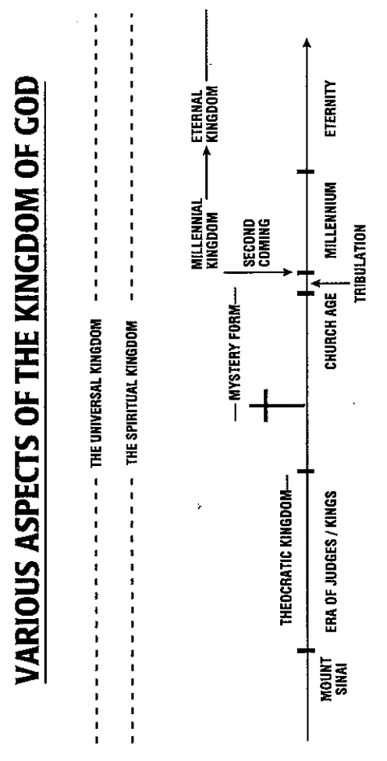[28]

God reigns supreme over all His creation and those who belong to Him will share in His triumph in His future eternal kingdom. Despite the severity of the persecution or the apparent might of earthly rulers, the enemies of God cannot thwart the ultimate victory promised to God’s saints when they share in His kingdom. Daniel promises that ultimately the eternal kingdom of God – His ultimate dominion over all creation – will be ushered in by the Son of Man.

A brief survey of the ultimate establishment of God’s kingdom:

* Daniel 2
  + This chapter tells of a coming kingdom – after four great world kingdoms – that will decisively crush and replace the reigning Gentile kingdoms.
  + In a recurring dream, Nebuchadnezzar saw a statue made up of various parts, parts which Daniel explained referred to those Gentile kingdoms.
  + The stone “cut out without hands” is God’s kingdom which strikes the feet of the statue and becomes “a great mountain and filled the whole earth” (2:34-35).
  + The kingdom of God will “crush and put an end to all these kingdoms” and “will itself endure forever” (2:44).
* Daniel 7
  + This chapter parallels chapter 2 by describing a series of four Gentile kingdoms that will rule before God’s earthly kingdom is established.
  + In a vision, Daniel saw four great beasts, beasts which parallel the four parts of the statue that Nebuchadnezzar saw in his dream in chapter 2.
  + The godless kings and kingdoms of the world are ultimately epitomized by the archenemy of God, the Antichrist, who will run roughshod over God’s people for 3.5 years (7:25).
  + His triumph will not last, however, for “his dominion will be taken away, annihilated and destroyed forever” (7:26).
  + When this happens, “the sovereignty, the dominion and the greatness of all the kingdoms under the whole heaven will be given to the people of the saints of the Highest One; His kingdom will be an everlasting kingdom, and all the dominions will serve and obey Him” (7:27).
  + When the kingdom of God comes, the saints take “possession of the kingdom” (7:22) and His people are vindicated and rewarded.
* Daniel 12
  + This chapter describes three events that will occur prior to the arrival of God’s kingdom:
    - First, will be a time of great distress for the people of Israel (12:1a).
    - Second, Israel will be rescued (12:1b).
    - Third, there will be a resurrection (12:2).
  + When these three events are complete, the kingdom of God will arrive on the earth.

Upon the establishment of God’s earthly kingdom, “the saints of the Highest One will receive the kingdom and possess the kingdom forever, for all ages to come” (7:18). “God’s people…will live again to participate in the dominion that was of the very essence of the mandate man received from the beginning”[29] (cf. Gen 1:26-28; Ps 8:5-6).

1. The Messiah

The agent of God who vanquishes God’s earthly enemies and ushers in His earthly kingdom is the “Son of Man,” the Messiah, who appears several times in Daniel’s prophecy. Daniel presents Messiah, not simply as the One who would redeem Israel, but more broadly as the coming future King over God’s earthly kingdom. “The historical kingdoms of this world and that of the Antichrist in the end of this era will give way to that glorious kingdom of God ushered in and ruled over by the Son of Man and the saints of the Most High.”[30]

The answer to the evil incarnate in the form of the little horn, the ruthless human dictator embodied in the Antichrist who stops at nothing to accomplish his selfish ambitions (7:8), is “the Son of Man” (7:13). The Messiah will receive eternal dominion (7:14) from the hand of “the Ancient of Days” (7:9), that is God the Father (cf. 1 Cor 15:27; Eph 1:20-22; Phil 2:9-11; Rev 19:15-16; 20:4-6). “[T]he coming Messiah would not only be the true David, but He would also be the true Son of man, combining in His person the high calling of humanity and the position reserved alone for God. His heavenly origin was stressed in that He came ‘with the clouds of heaven (7:13)…and His divinity was underscored by the abiding and indestructible kingdom and dominion that was given to Him (7:14).”[31]

Likewise, Daniel’s vision of the 70 weeks in Daniel 9:24-26 speaks of the Messiah who will accomplish six things. “The first three relate to Messiah’s atonement and dealing with sin in regard to Israel’s transgression against God. The last three relate to Messiah’s kingdom when it is established. While the basis for these matters is found in Jesus’ death at His first coming, the full realization of these predictions awaits the coming of His kingdom.”[32]

## Purposes of the Book

1. Daniel’s personal dedication to God (Dan 1) would have been an example to the deportees on how they should live in a heathen society. Daniel served as an outstanding example of godliness to the exiles (cf. 6:4).
2. The book emphasizes God’s sovereign authority over Gentile nations, how He establishes and deposes kings and empires to serve His purpose.
3. The book gives an example of God’s faithfulness to His covenant people in protecting and preserving them even though they were under divine discipline for their disobedience. It assures them that God does not cast off His covenant people but rather deals patiently with them to bring them to blessing.
4. The book was also written to outline graphically the prophetic period known as “the times of the Gentiles” (Luke 21:24) which refers to the time period when the Jewish people live under ungodly, Gentile, world dominion between the Babylonian captivity and the Messiah’s return. The book carefully and in detail shows the effect the Gentile nations will have on Israel while she is waiting for God’s covenants to her to be fulfilled under the Messiah’s reign. It provides a panoramic sweep of human history during Gentile domination from Daniel’s own day until the establishment of God's kingdom upon the earth. As such, its purpose was to exhort Israel to be faithful to the sovereign God during the times of the Gentiles.
5. Daniel’s book also reveals Israel’s future deliverance and the blessings she will enjoy in the coming Millennial Age. As God covenanted with Abraham, his descendants will occupy the land God promised them. Even though the nation must be disciplined because of her disobedience, she will be brought to repentance, confession, and restoration. God will preserve His covenant people and guarantees them ultimate blessing in their covenanted kingdom on this earth in the future.

## Main Problems in Daniel[33]

The following list contains the primary interpretive challenges that must be dealt with in studying and teaching Daniel:

* How is the “third year” of 1:1 reconciled with the “fourth year” in Jeremiah 46:2?
* Why is 2:4b in Aramaic rather than Hebrew?
* How is the meaning of the second, third, and fourth empires in chapters 2 and 7 determined?
* Did Nebuchadnezzar become a true worshipper of God (chapter 4)?
* What evidence exists for the historicity of Belshazzar (chapter 5)?
* What evidence exists for how Babylon was conquered (chapter 5)?
* Who was Darius the Mede (chapters 5 and 6)?
* Should the fulfillment of the kingdom in chapter 7 to be understood in the amillennial or premillennial sense and why?
* Is the “little horn” in chapter 7 (vs. 8) the same one as the “small horn” in chapter 8 (vs. 9)?
* Who is the “One like a Son of Man” in 7:13-14?
* What do the “2,300 evenings and mornings” in 8:14 refer to?
* Where does the Antiochus of the past end and the Antichrist of the far future begin in 8:23-25?
* When do the 69 weeks of 9:24-26 begin and end and what proof indicates this?
* When is the 70th week of 9:27 and why?
* Is the Antiochus of 11:21–35 still meant in 11:36–45 or is it the future Antichrist?
* What book is meant in 12:1? A book of those who physically survive the Tribulation or a “book of life” including the names of those who are saved as in Rev 3:5; 20:12, 15; 21:27?
* What do the “1,290 days” and “1,335 days” in 12:11-12 refer to?
* When does the resurrection in 12:2 occur in the eschatological timeline?

## Flow of the Book

1. Observations about the Flow
2. First observation: The use of two languages in the book (Hebrew – chapter 1; Aramaic – chapter 2-7; Hebrew – chapter 8-12) must be taken into consideration when determining the flow and outline of the book.
3. Second observation: “Chapter 7 seems the climactic piece of the Aramaic ‘stories’ section and yet it is not a story but a vision. So language-wise chapter 7 belongs to 2-6 and yet category-wise, as a vision, it introduces a series of visions (8-12) and itself stands as the first vision in chronological sequence (7:1; 8:1; 9:1-2; 10:1). Chapter 7 then has an overlapping function in the book’s structure. It both climax and preface.”[34]
4. Third observation: A chiastic pattern for chapters 2-7 likely exists, a pattern which accurately follows the themes of the text. It may be summarized as follows:

Vision of the four world empires (2)

Deliverance of Daniel’s friends from the fiery furnace (3)

Judgment of Nebuchadnezzar – resulting in repentance (4)

Judgment of Belshazzar – resulting in death (5)

Deliverance of Daniel from the lions’ den (6)

Vision of the four world empires (7)

The purpose of this structure points to the theme of God’s sovereignty and control described in Daniel 4:34-35 ~ But at the end of that period, I, Nebuchadnezzar, raised my eyes toward heaven and my reason returned to me, and I blessed the Most High and praised and honored Him who lives forever; For His dominion is an everlasting dominion, And His kingdom endures from generation to generation. All the inhabitants of the earth are accounted as nothing, But He does according to His will in the host of heaven And among the inhabitants of earth; And no one can ward off His hand Or say to Him, ‘What have You done?’



1. Outline

Daniel: God’s Rule over History[35]

I. God’s Rule in Bringing Daniel to Babylon (Daniel 1)

II. God’s Rule over World Empires (Daniel 2-7)

1. Nebuchadnezzar’s Dream of the Great Statue (2)

(God’s Rule over Four World Empires)

1. Nebuchadnezzar’s Golden Image (3)

(God’s Rule Preserves Daniel’s Friends in the Fiery Furnace)

1. Nebuchadnezzar’s Dream of the Tree (4)

(God’s Rule Humbles Proud Nebuchadnezzar)

1. Belshazzar’s Feast (5)

(God’s Rule Judges Forgetful Belshazzar)

1. Darius’ Decree (6)

(God’s Rule Preserves Daniel in the Lions’ Den)

1. Daniel’s Dream of the Four Beasts (7)

(God’s Rule over Four World Empires)

III. God’s Rule over Israel’s Future (Daniel 8-12)

1. Daniel’s Dream of the Ram, the Male Goat, and the Little Horn (8)

(Israel’s Persecution)

1. Daniel’s Prayer and the Prophecy of the Seventy Weeks (9)

(The End of Israel’s Persecution)

1. Daniel’s Vision of the Heavenly Messenger and His Message (10-12)

(Israel’s Persecution and Restoration)

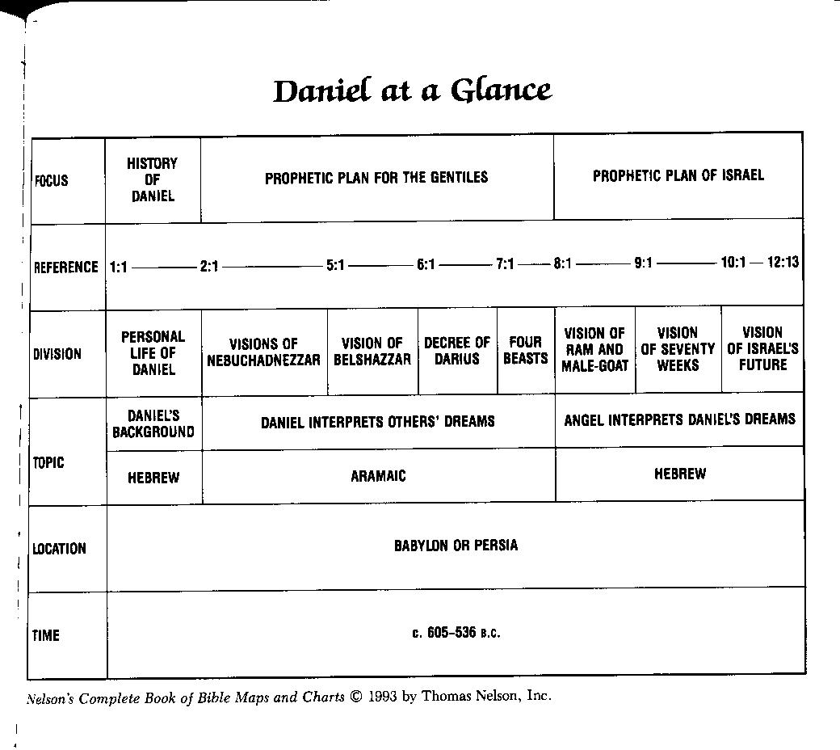

1. Miller 1994: 35.
2. Merrill, Rooker, and Grisanti 2011: 405-406.
3. Ibid., 406.
4. Archer 1994: 423.
5. Merrill, Rooker, and Grisanti 2011: 406.
6. Whitcomb 1985: 78.
7. Archer 1994: 430.
8. Ibid., 430.
9. Miller 1994: 29.
10. Ibid., 30.
11. Ibid., 31.
12. Archer 1994: 437.
13. Ibid., 438.
14. Miller 1994: 41-43.
15. Archer 1994: 434.
16. Miller 1994: 48.
17. Miller 1994: 45.
18. Merrill, Rooker, and Grisanti 2011: 409. This list is taken from John J. Collins, *Daniel,* Hermeneia (Minneapolis: Fortress, 1994) who holds that Daniel is pseudonymous. Hence the inclusion of *ex eventu* prophecy in this list.
19. Miller 1994: 47.
20. Whitcomb 1985: 17.
21. Eugene Merrill, “A Theology of Ezekiel and Daniel,” in Zuck 1991: 388.
22. Ibid., 390.
23. Ibid., 390.
24. Ibid., 392.
25. Kaiser 1991: 244.
26. Vlach 2017: 207.
27. Eugene Merrill, “A Theology of Ezekiel and Daniel,” in Zuck 1991: 395.
28. Chart taken from Benware 1995: 145.
29. Eugene Merrill, “A Theology of Ezekiel and Daniel,” in Zuck 1991: 395.
30. Ibid., 395.
31. Kaiser 1991: 246.
32. Vlach 2017: 217.
33. This list was adapted from a similar list in the *Daniel – BI762A* syllabus by TMS professor Dr. James E. Rosscup, Fall 2001.
34. Davis 2013: 22.
35. Whitcomb 1985: 18.