You Believe What?!?

Week 1: Where do we root our beliefs?

Introduction to the series
- The overall goal of this series is for us to find out why we believe what we believe.
- We should never believe a doctrine because a church teaches it, a person teaches it or because we think that it makes sense to believe it. We must be able to search the Scriptures for ourselves.
- Right now, the perspicuity of Scripture is under heavy attack. It is not coming from the usual suspects, liberal theologians, progressive Christians or social gospel warriors.
- What is being said is that the individual believer cannot understand what the Bible is actually saying without some sort of help.
- What is the help that people need? It’s the creeds, confessions and teachings from men long ago.
- “Did you know that many of the reformers taught churchgoers the catechism for years prior to giving them unbridled access to the scripture?”
  - The attack is coming from men who are conservative, evangelical believers.
- It's becoming increasingly common for some theologians to mock individual Bible study. Picking up the word of God, reading it for yourself, and heeding what the Lord has said can be couched in language that makes the process sound like a fool's errand. These theologians will claim that without the help of historical secondary sources, it's nigh impossible for an individual to understand the biblical text in accordance with historic Christian orthodoxy.

Schedule for Classes:
- 07/23: Creation Trip Presentation
- 07/30: Introduction and the Purpose of the class.
- 08/06: Why should the Bible be our firm foundation? Part I
- 08/13: Why should the Bible be our firm foundation? Part II
- 08/20: Where do we find our church doctrines? Part I
- 08/27: Where do we find our church doctrines? Part II
The overall goal is to take some vital doctrines and learn how to exegete the text and defend the faith.

Why this topic matters.
- If our modern-day church / Christian is not able to understand, interpret and apply the Scripture on their own, then we must look for a secondary source to help along the process. If the church looks for a secondary source, the obvious question should be…is that secondary source the authoritative source?
- “Thomas Aquinas is experiencing a revival in the 21st century. This unholy ‘revival’ is occurring in conservative seminaries, many with a Reformed pedigree. One example is the Master’s Seminary. The spring 2022 issue of The Master’s Journal featured an interview with Dr. Matthew Barrett of Midwestern Baptist Theological Seminary. He touted Thomas Aquinas as ‘the most useful scholar of the Middle Ages on the Trinity.’ and an indispensable source for seminary education of Bible-believing ministers. The Master’s Journal includes other citations and even articles from other champions of Thomas Aquinas and the ‘Great Tradition’ he represents. They include R.C. Sproul, Dr. James Dolezal of Cairn University, and Dr. Craig Carter of Tyndale University.”
- This matters because these men are starting to influence unsuspecting and unknowing Christians into thinking that the Roman Catholic Church (RCC) is the true church.
- Steve Meister (The Master’s Seminary graduate, current pastor at Immanuel Baptist Church) says “I once held dispensationalism…biblicism. What changed? In a word, hermeneutics. I came to see my interpretive assumptions were modernist, self-defeating, and inconsistent with Christianity prior to the 19th century.”
  - Meister rightly admits that he was reading the Bible without firstly looking to the creeds, confessions and philosophy prior to the 19th century.
- James Dolezal (The Master’s Seminary graduate, current Asst. Prof. of Theo. At Cairn Univ., PA), “Dolezal’s insistence that the Bible must be understood through the lens of an Aristotelian metaphysic.”
  - In other words, Dolezal believes that the Bible is best understood through the confessions and creeds and philosophical insight; not just simply reading the text.
- Southern Evangelical Seminary (Norman Geisler), “In the decade from 2004 to 2014, more than two dozen faculty members, students, and alumni of SES have entered into full communion with the Catholic Church. Keeping in mind that only around two dozen students graduate from SES each year, this is rather a significant percentage.”
  - One convert, Douglas Beaumont, wrote “So if what the Bible was, and how it was to be understood, were not grounded in a God-guided, infallible process—then what else was there to trust?”
  - He would go on to say “…the fact of authoritative Church councils weighed heavily on me. They essentially were the answer to the above issues of canon and orthodoxy, and they also pointed to what the historic Church was—if the Catholic Church was behind the councils that determined the biblical canon and its orthodox interpretation, was it God-guided or not?”
  - Notice that he is talking about authority. This is a major, MAJOR difference between the RCC and Protestants. These men are pointing to either the church or the creeds / confessions for their authority, not the Scriptures.
- These men, and many more, are teaching at some of the highest levels and influencing the next generation of pastors and teachers. Therefore, they are also influencing the church and the books which are circulated throughout the church.
- As Christians, we look to the Scripture as our authority, and we also look to our historic Christian faith. Not so much for helping in understanding the Scriptures, but to make sure that we are not off in our thinking.
- While these men have not said it, they are treating these manmade confessions as inerrant and the only way to actually know what the Bible says.
- Why is it important to know why we believe what we believe…because if we don’t, we are going to be swayed by people who seem to have great training and knowledge.
- If you are not able to go back to the Scriptures and stand on God’s infallible Word, then your hope is in something that will change and ultimately fall under the weight of truth.

sola scriptura or solo scriptura?
- “To reach our separated brethren within Fundamentalism and Evangelicalism, we must display, gently yet relentlessly, the shortcomings of sola scriptura.”
  - Jason Evert, RCC apologist and missionary to the Evangelicals.
  - I find it fascinating that the RCC and the Reformed confessional people are all trying to get the rest of Christianity away from Sola-Scriptura.
- The starting place for these men (RCC and Reformed) is simple, modern reformed Christians have replaced sola scriptura with solo scriptura.
- Sola Scriptura (scripture is the sole, infallible authority for faith and practice)
- Solo Scriptura (one’s own, interpretation of scripture is the sole, infallible authority for faith and practice)
- “In truth, theology should be a process of study, evaluation of presuppositions, reformulation, and clearer articulation, all against the backdrop of doctrinal precedent.”
- To a great degree, we would agree with this statement. Our theology should always be based upon a process of study. But the author does not say what we are to be studying.
- We should also evaluate our presuppositions or what we believe as we come to the Scriptures for our study.
- Once again, while we should reformulate our wrong beliefs, the question that is not answered is how do we know that our beliefs are wrong? Is it according to the Scriptures or historical theology?
- Our goal in studying should always be clearer articulation, no argument.
- Here’s the part that should peak your discerning ears…all against the backdrop of doctrinal precedent.
  - In case you don’t know…doctrine means a belief or set of beliefs taught by the church.
  - Precedent means something that happened earlier that should be considered a guide in subsequent similar circumstances.
  - To put that together, we need to know what the early church taught in order to have our theology correct for today.
- Do you see what is missing here? What happened to the authority of the Scriptures to be able to stand alone, without the help of man’s creeds or confessions?
- What the author is advocating, is that if you believe something today that was not affirmed by the early church, through the creeds / confessions, then you are going down the line of heresy.
- In fact, he says “Have you inadvertently become a ‘mini-pope,’ making yourself the arbiter of orthodoxy?”
- Pay attention to what he is saying, if you go back far enough in church history and find out that your modern-day beliefs do not align with what they taught / thought, then you have put yourself as the authority.
- “From the time of Augustine to Aquinas, Trinitarianism was guarded well. The ecumenical centralization of Christianity ensured that the boundaries of cardinal doctrines, such as the Trinity, were kept in check by the creeds until the Reformation. Those Creeds continued to guide the magisterial reformers and Puritans as well.”
- Once again, we need to really press this idea that he is implicitly teaching. The church’s beliefs were only as strong as their acceptance and reliance on the creeds.
- The church stayed unified as long as they accepted the creeds, not necessarily what the Scriptures taught.
- While the author never says this, what he is supporting (hopefully ignorantly), is the idea that the church would have collapsed or fallen if not for man’s creeds.
- Even worse (in my opinion) is the fact that he downplays the Reformation.

The Great Tradition
- Those who support the idea of Scripture plus history often times refer to the Great Tradition.
- “…those bedrock beliefs of the Bible, the early church, the creeds, the Reformers, and orthodox Christians throughout the ages.”
- “Those who follow the Great Tradition argue that the Nicene Creed and the pro-Nicene Fathers, along with the six other ecumenical creeds of the early church, capture the fundamentals of the Christian faith and set the standard for orthodoxy.”
- I want to make sure that this point gets through…we do not believe that our current doctrine should not align with what has been taught and accepted throughout church history. Furthermore, we would affirm much of what has been written in the creeds and confessions.
- The idea that we vehemently oppose is that those creeds / confessions have more or equal authority as the Scriptures. Also, we do not believe that one needs to have these creeds / confessions in order to understand the Scriptures or for a church to function properly.
- If our doctrine does not agree with what was held to in church history, we do not automatically change our doctrine. But we search the Scriptures to find out why.
- How are we to come to our beliefs as we search the Scriptures?

The importance of our own exegetical theology
- This is a major point of contention, exegetical theology VS. historic theology.
- “The classical theists tend to so honor the Church Fathers that they and their so-called Rule of Faith become the actual authority, even trumping Scripture. The classicalist would push back and claim that the Rule of Faith, the Great Tradition, and such compilations, are simply summaries of biblical teachings; they do not preempt Scripture. But in reality, they sometimes do, and any challenge or even inquiry into the ancient Church Fathers’ views is deemed to be heresy.”
- While we would agree with much of what our historic brothers taught for the past 2000 years, their hermeneutic (how they interpreted the Scriptures) was usually left wanting.
- Much of church history has been shaped by the uses of allegorical, typological, Christocentric and contemplative hermeneutics. The idea of a grammatical-historical hermeneutic was rarely, if ever, in the prevue of the medieval church.
- Their goal was to find the “senses” of Scripture or the “meaning” behind the meaning.
- These new proponents of the Roman Catholic Church (my words, not theirs), tell us to just trust the exegetical work of all the church fathers and leaders who have come before us…without question.
  - The main issue is that if their hermeneutics were off and they were worried about proper exegesis, then their findings are going to be off too.
- Matthew Barrett says, “All that to say, evangelicalism’s narrow outlook on history and striking ignorance of patristic and medieval theology has resulted in a neglect of orthodox trinitarianism, leaving evangelicals easy buyers for modernity’s novel sell of social trinitarianism.”
- Essentially, what Barrett is saying is that anything after the Reformation should be suspected of being influenced by the Enlightenment.
- He would support that there is no way that someone who is saved, filled with the Holy Spirit could understand the Scriptures without knowing medieval theology.
- If one does not understand metaphysics and the allegorical interpretation of Scriptures according to Aquinas, they have fallen short and may not have the salvation they profess.
  - To be fair, he has never said that one is not saved, but also to be fair, it is the road he is traveling down.

Modern Day Biblicists
- As opposed to those who consider the creeds / confessions as their “rule of faith,” there are Biblicists.
- Biblicism is a method of personal Bible study that rejects pre-conceived systematic theologies in order to understand Scripture on its own terms.
- To be sure, this is a derogatory term meant to bring the weight of foolishness down upon anyone who would think to read the Bible and apply its truths without the help of Aquinas (and others).
- Taken from a pro-credal person, he defines a Biblicist as someone who believes:
  - The Bible is identical to God’s own words.
  - The Bible is what God wants us to know and all God wants us to know in communicating the divine will to us.
  - Everything relevant to the Christian life is in the Bible.
  - Perspicuity—any reasonable human can read the Bible in his or her language and correctly understand the plain meaning of the text.
  - Commonsense hermeneutics—the plain meaning is in the text.
  - All passages on a given theme mesh together.
  - The Bible is universally valid for all Christians, wherever and whenever.
  - The inductive method—read it and put it together.
  - The Bible is intended by God to be a handbook or textbook for the Christian life.
- If you didn’t catch it…we would pretty much agree with what McKnight considers an insult. We would say that in order to hold to the sufficiency and authority of Scripture, these things are essential to believe.

Why the attack on Biblicists?
- “Proponents of the prioritization of historical secondary sources in Bible study encourage a person's theology to be mostly developed before he draws out theology from Scripture. If a person goes to the Word himself, they say, he is much more likely to conjure a variety of doctrines that are not in accord with sound teaching. Left to his own devices, the individual -- born-again or otherwise -- is missing out on the fullness of Christianity if he just has the Bible. He must be taught theology before he is sent off on his own in Bible study.”
- These men emphasize ideas like the “Great Tradition”, the apparent need for “Christian Platonism” as Craig Carter and others espouse.
  - Carter writes “What is known by revelation does not contradict what is known by philosophy, but it deepens, supplements, and sometimes corrects our mistakes in reasoning. Philosophy and theology work together in the task of speaking truthfully about the one, true, God.”
  - The problem with this quote is that it tells people that they are at a severe disadvantage if all they have is the Bible. In fact, he is saying that Scripture alone is inadequate for one to arrive at the proper understanding of Biblical doctrine.
- To some, this is a functional denial of Sola Scriptura as they seem to imply that Scripture alone is not sufficient, because according to these men we need Thomistic Aristotelian metaphysics and/or Platonism and/or specific creeds as lenses in order to be orthodox and interpret Scripture properly.
- These academic men believe that they are standing in the gap between modern enlightened Christianity and the orthodox true church. They are literally calling believers back to the one true faith, which is (in my opinion) nothing short of promoting the Roman Catholic Church.
- So, this is the conclusion of anti-biblicism: The Bible is not sufficient in itself to safeguard the truth for us individually, even when it is interpreted in context; therefore, we must add formally written extrabiblical documentation to serve as a governing authority for our doctrine.

Practical Theology,
Missions, Counseling,
Apologetics,
Ministry Philosophy

Homiletics
Hermeneutics (Rules of Interpretation) The Foundation for how you view the Scriptures and how they should be interpreted.
Biblical Introduction / Biblical Languages / Canon of Inspired Scripture

Biblical Exegesis (the actual interpretation or leading out) looking at verbs, nouns, grammar, syntax, etc.

Biblical Theology / Historical Theology
Systematic Theology

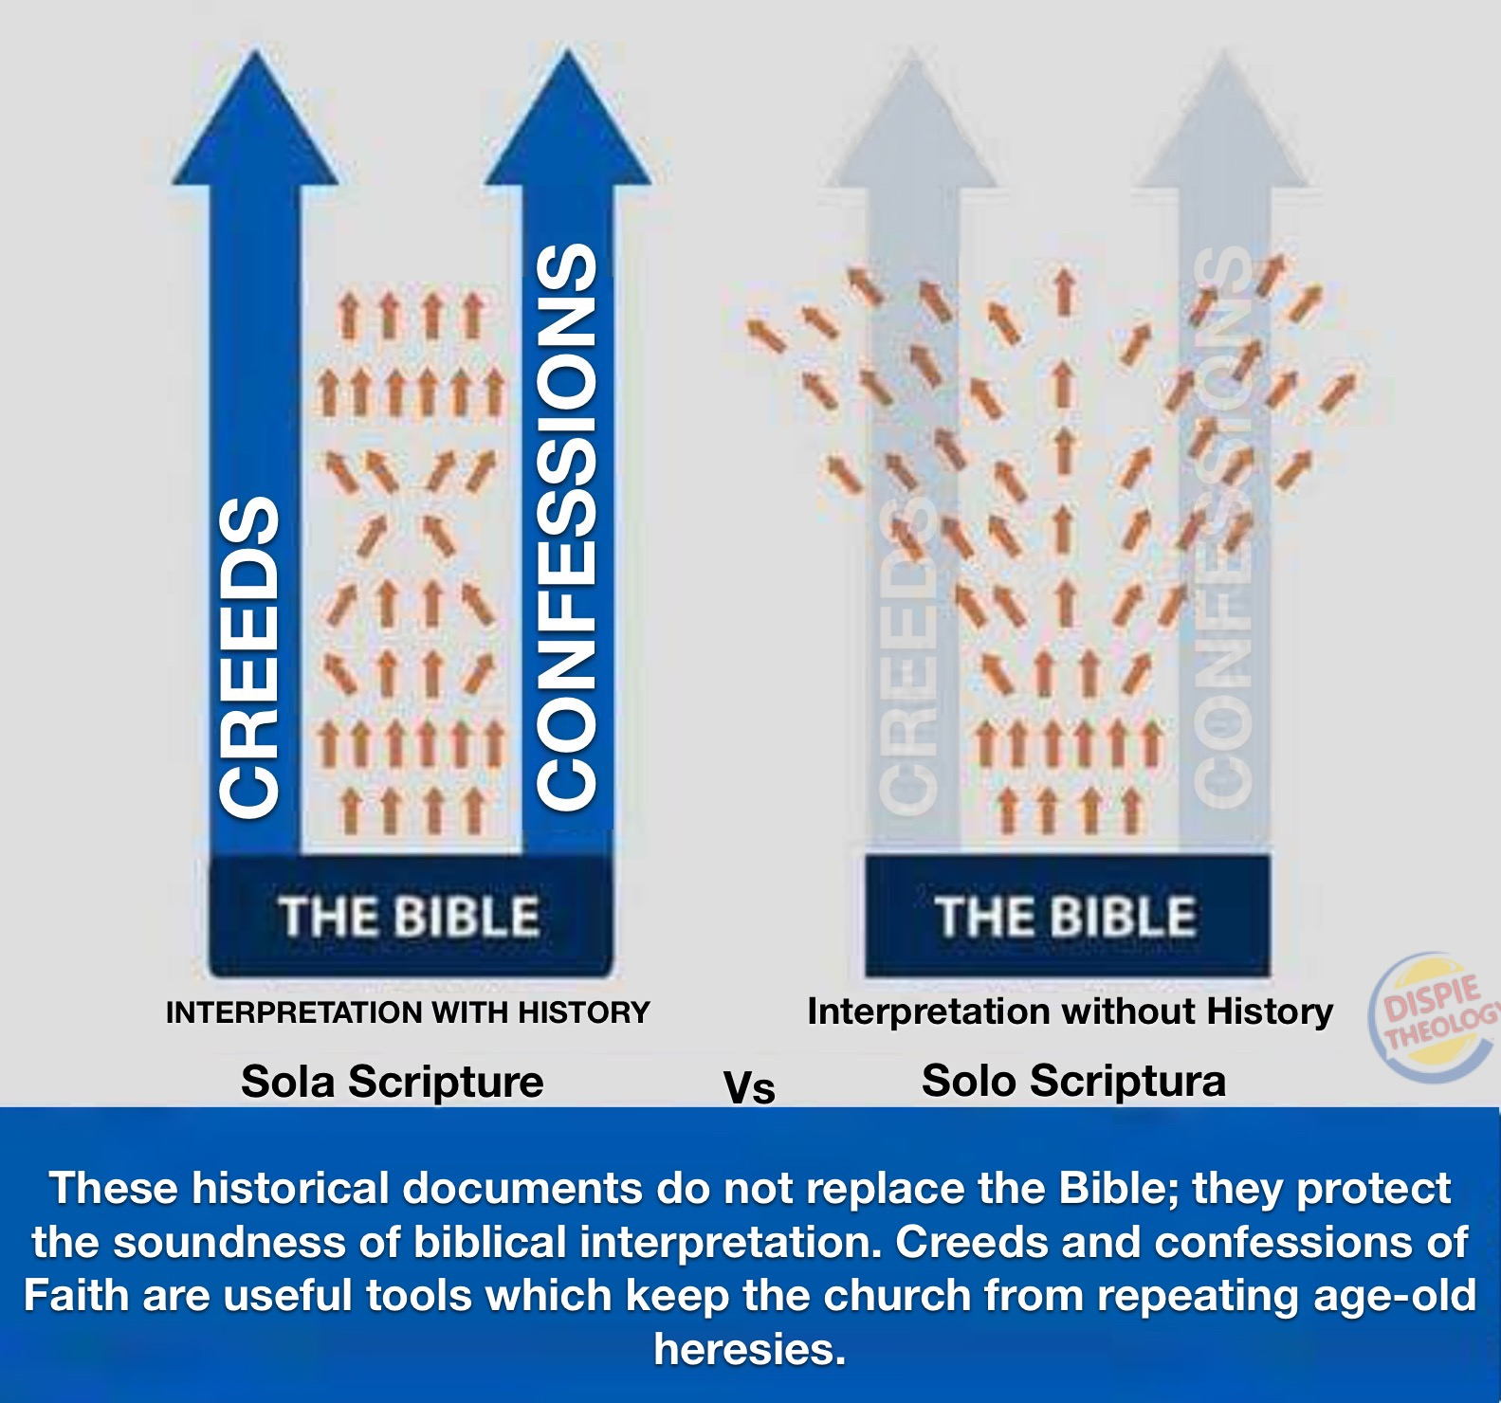

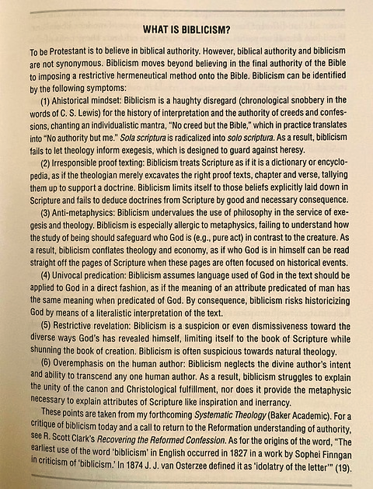

https://twitter.com/MattMBarrett/status/1516401230234456064 This quote is from Matthew Barrett, professor of Christian Theology at Midwestern Baptist Theological Seminary and author of multiple publications. He is a leading evangelical scholar who is seeking to bring Protestants back to their Roman Catholic faith.
https://www.jeremyhoward.net/2022/07/biblicism-confessions-womanhood.html
https://bereanbeacon.org/reformed-leaders-hypnotized-by-catholic-teachings-of-thomas-aquinas/#_edn12
https://www.jeremyhoward.net/2022/07/biblicism-confessions-womanhood.html
https://exegesisandtheology.com/2017/12/21/review-of-james-dolezal-all-that-is-in-god-evangelical-theology-and-the-challenge-of-classical-christian-theism/
https://www.catholicworldreport.com/2016/07/19/evangelical-exodus-the-protestant-seminary-that-produced-dozens-of-catholic-converts/
Ibid.
Ibid.
https://www.catholic.com/magazine/print-edition/mission-to-mission-to-catholics
https://credomag.com/article/the-angelic-doctors-heavenly-doctrine-of-god/
Ibid.
Ibid.
https://juicyecumenism.com/2013/09/04/the-great-tradition-the-essential-guidance-system-for-the-church/
https://tottministries.org/the-battle-for-god-part-5/
Ibid.
Ibid.
Ibid.
https://www.jeremyhoward.net/2022/07/biblicism-confessions-womanhood.html
https://tottministries.org/the-battle-for-god-part-5/#_edn29

