OT Survey: Prophets
Week 5: The Persian Period – Daniel and Joel

Introduction to the series - Recap
- Two goals: to have a general working knowledge of each of the prophetic books in the Old Testament and to have the confidence to be able to study them on our own.
- As we study these books, we want to pay special attention to what God is doing through these prophets, how the prophets themselves respond, what the message of the prophets is, and how those being prophesied to respond to their words.
- These will be overviews of the books in each group. It will also dive into some of the areas of special interest to us in order to learn about what is going on in each book.
- Jonah, Amos, Hosea, Micah, Isaiah: The Prophets of the Neo-Assyrian Period
- Zephaniah, Habakkuk, Jeremiah, Nahum, Ezekiel, Obadiah, Lamentations: Prophets of the Neo-Babylonian Period
- Daniel, Haggai, Zechariah, Joel, Malachi: The Prophets of the Persian Period
  - 12/08: Daniel & Joel – The Prophets of the Persian Period

The book of Joel
- Background to the Book
  - Author is Joel, son of Pethuel, of which there is no other information on either. Joel (Yoel) means Yahweh is God. The author’s name is given in Joel 1:1, but there is no context on when it was written, as other books do provide.
  - Verse 2 moves directly to the description of a (literal? likely) plague of locusts
  - Date of authorship is unclear; there are 3 main views on when it was written:
    - Pre-exilic, ~800 BC
    - Late Pre-exilic, between 597 BC and 587 BC, around the time of the 2nd wave of exiles to Babylon.
    - Post-exilic, after (approx..) 539 BC
    - A large number of commentators place book at the Late Pre-exilic date, from the fact of the textual descriptions of Temple practices and Priestly duties, the destruction of sacrificial things by the plagues of the locusts – grain, which would also eliminate the animals used for sacrifice, and grapes needed for wine.
    - The timing is also suggested by the placement of the book in the Hebrew TaNaKh and OT Canon, after Hosea (1st of the Minor Prophets) and before Amos. This is reinforced by the fact that there are ties between passages in Hosea to Joel, and between passages in Joel to Amos.
      - In the TaNaKh, the Jewish scriptures, our OT Minor Prophets are considered one book, the Book of Twelve. Just as with Psalms, in which it is understood that there is a composer who organized the Psalms into books (I – V, with themes to each book), the Book of Twelve is arranged by a composer.
      - “It is possible to talk about authorship of the Twelve on two different levels. On the one hand, there are twelve separate works . . .. On the other hand, there is internal evidence that an unnamed final composer brought these works together in a single composition.”
    - There are a number of scholars who put Joel in an Early postexilic period, around 530 BC. That fits with the second section of the book, which describes the restoration of Israel and the rebuilding of the Temple.
    - But the date of writing does not have bearing on the message of the book.
  - Joel was written to Judah

- Theme and Purpose of the Book
  - The theme of Joel is “The Day of the Lord”, which is specifically mentioned 5 times. This theme is also found in many of the OT prophets as well as other references to “that day” and “the great day”
  - The Day of the Lord has eschatological significance, but in this book takes on symbolic meaning also, with the plague of the locusts (1:2-20) and the description of the invading army (2:1-17).
  - The eschatological significance is particularly present in the Minor Prophets.

  - The Day of the Lord is not only about judgment, but also about restoration. And that is the case with Joel. So, an outline of the book is:
    - I. The Plague of Locusts [symbolic invasion] (1:1-20)
      - A. Mourn (1:1-12)
      - B. Repent (1:13-20)
    - II. The Day of the Lord [literal invasion] (2:1-32)
      - A. Evening of the DotL – Judgment of Israel (2:1-17)
      - B. Morning of the DotL – Restoration of Israel (2:18-32)
    - III. Judgment on the Nations (3:1-21)
      - A. For their Mistreatment of Israel (3:1-15)
      - B. The Lord is a Refuge for His People (3:16-17)
      - C. The Lord will Bless Judah and Jerusalem Forever (3:18-21)

- Overview of the Book
Chapter 1 describes what is likely a recent event of an invasion of locusts. It occurs in 4 phases – the “gnawing” locust, the “swarming” locust, the “creeping” locust, and the “stripping” locust.
  - It is a picture of total devastation. Fields of grain are totally devastated, and fruit trees and vines dried up.
  - The result is that what is needed for Temple offerings – grain, new wine, etc. – are gone. Animals used for sacrifice would die, having no food to eat. Brooks dry up. The priests are to lament, and joy has left the nation. Even the drunkards who relied on the fruit of the vine for their reveling weep and wail (v. 5).
  - With no food or drink, the people will not be able to survive.
  - But the message is also a call to repentance and restoration: Elders and Priests are to repent, proclaim a solemn assembly and fast, and assemble the nation to the house of the Lord, crying out to the Lord (v. 19) for the devastation that has been wrought on the nation.

Chapter 2, in the first 17 verses, is a description of an invading army from the north (v. 10). Watchmen are to sound the alarm for the judgment coming.
  - It is a day of darkness and gloom, clouds over all the land, with fire before and after them, chariots and war horses, and an army in battle array.
  - Destruction is unavoidable (v. 3). It is a description of the total devastation to come at the Day of the Lord.
  - ‘Taking a late pre-exilic date of Joel’s writing, it would be a prophetic vision of the coming invasion of the Babylonians’. But given the absolute and total devastation, it is also a foretelling of the judgment of the Day of the Lord. And given that Joel is part of the Jewish Book of Twelve (compiled in the post-exilic period the prophecy would be “not yet fulfilled but seen as pointing to events in the future.”
  - It is clear (v. 11) that this army is carrying out the Lord’s judgment, which reinforces that it is more significant than merely an invading army, but symbolic as well of the coming and ultimate Day of the Lord.
Chapter 2 in the last 15 verses (vv. 18-32) describe the Restoration that God promises in 3 aspects
- The Lord is zealous, merciful, and has pity on the nation (v. 18). The picture which the words form is that of a husband jealous for any dishonor to the wife He loves.

- The Lord restores the Land (vv. 19-27).
  - He will provide an abundance of grain, wine, and oil, restoring what is needed for the Temple, and food for the people. He will remove the northern army to a parched and desolate land. There will be a complete turnabout from desolation to overflowing abundance.
  - The Lord will make up the years that were lost by the invasions – both the locusts and the invading army. And he will remove the people’s shame (v. 26). The idea is that of taking away the disapproval of those nations around them.
  - Verse 27 restates the truth that the nation will never again be ashamed, reinforcing its certainty.
  - Verse 26-27 state that the people will have plenty to eat, to their satisfaction, and will praise God, who has dealt wondrously with them. It recalls God’s Shekinah glory going with His people in the Exodus.
- The Lord Provides Spiritual Renewal (vv. 28-32)
  - These verses describe events in the distant future, specifically around the eschatological Day of the Lord, and describe what it typically known as the Tribulation.
  - First, in verses 28-29 describe the pouring out of God’s Spirit on His people. They are widely referenced in other parts of the Scripture, directly quoted by the Apostle Peter in his sermon on the day of Pentecost, but also referenced in Isaiah (32:15, 44:3), Ezekiel 39:29, and Zechariah 12:10. Peter announced that Joel’s prophecy of the pouring out of the Spirit had been fulfilled that day, testified by the signs on those present.
  - The evidence of the pouring out of the Spirit will be signs and wonders – prophecy, dreams, and visions.
  - Second, with verses 30-31, the text speaks of tremendous events that take place – the sun to darkness, the moon to blood, gloom, wonders in the sky and on the earth – on the Day of the Lord.
  - And third, the final deliverance will come for those who have called on the Name of the Lord. This will take place on Mount Zion in Jerusalem. Again, this is confirmed in passages in Revelation and others.
Chapter 3 describes the judgment on the nations, and greater detail of the restoration and establishment of Judah and Jerusalem.
  - The nations around Judah will be judged; Tyre, Sidon and Philistia are specifically mentioned; later, Egypt and Edom.
  - There will be a great war in the Valley of Jehoshaphat, and the nations will be “harvested” with a great sickle. This valley is likely the plain of Megiddo as referenced in Revelation.
  - Finally, Zion will be blessed, and God will establish Himself as dwelling with Judah on His holy Mount of Zion. And the nation will be blessed forever, overflowing with wine, milk, and sweet water. Again, we have a prophecy that will be confirmed in John’s book of Revelation, as God dwells with His people forever. This is a foretelling of the Millennial Kingdom, the Messianic Age.

What are some key verses and concepts in the book?
- An obvious key verse in this book is Joel 2-28-29, the promise of the gift of the Spirit “after this”. It has already been shown that Peter looks back to Joel in his sermon. But we must not forget that at the end of Messiah’s first coming, when Jesus tells His followers that He is going away, He promises them the gift of the Spirit, and that it will be better for them that He goes so they receive this gift. We are told to walk – live our life – by the Spirit, so that we do not gratify the desires of the flesh (Gal. 5:16)
- Directly after this, Joel provides a description of the Day of the Lord, verses 30-32. As these verses, and much of Chapter 3 describe, this will be a time of global cataclysm, a terrible time of judgment of unbelievers, and deliverance for those who call on the name of the Lord – believers, who the Lord calls (v. 32).
- In chapter 3 verse 17, we are told that the people will “know that I am the Lord your God, dwelling in Zion, My holy mountain”, and that “strangers will pass through it no more”. The idea that “strangers” (unbelievers) will not be allowed where God resides with His people (also referenced in Is. 35:8-10, Nahum 1:15, and Zech. 14:20-21) describes the new covenant relationship, different than what is commanded of the people in Lev. 19:33-34 on how to treat the alien and stranger in the nations’ midst.

What is the main message of Joel?
Joel is clearly an eschatological book of prophecy concerning the End Times. It would be natural to be caught up in the descriptions of the plague of locusts and the invading army, and lose the clear message of the Day of the Lord and the restoration for eternity of those who call on the Lord – the Millennial Kingdom and beyond. In the Commentary on the Book of Twelve, Michael Shepherd concludes the section on Joel by stating:
“The success of the incorporation of the book of Joel into the overall program of the Twelve is attested by the citation of the book to explain the Pentecost event and to look forward to times of refreshing when Christ returns in the Day of the Lord (Acts 2-3). Here is the ongoing significance of the book as Christian Scripture for the church. It is indispensable for our understanding of the eschatological Day of the Lord in the Twelve, the Hebrew Bible, and in Christian theology.”
Other takeaways from Joel that we can see are:
- restoration begins with the Elders and Priests (2:16-17). Those in positions of shepherds of the flock are called to lead the church, holding fast to truth and restoring the people in the truth when they fall away or when times of trial come.
- The certainty of a future in the presence of the Lord provides the individual believer the hope that he or she needs to make sense of a daily life filled with trials, difficulties, sorrow, and pain.

The Book of Daniel

- Background to the Book
  - Daniel is, in many ways, a familiar book to us and at the same time a very obscure book.
  - We know the stories presented from early childhood – Daniel in the Lion’s Den; Shadrach, Meshech, and Abed-nego in the fiery furnace (or, as my Dad used to tell me the story at bedtime – Shadrach, Meshech, and To-Bed-We-Go ). This makes it a familiar book.
  - But it is obscure because there is so much symbolic language we encounter: the Four Beasts; the Ram and the Goat; the Horns, including the Little Horn; the Weeks – 70, 62; the Visions Daniel has and the Dreams he interprets, such as the handwriting on the wall (Mene, Mene, Tekel, Uparshin); the kings of the South and the North; global conflicts; the End Times, and the various days referenced.
  - All of this makes for a book that is both entertaining and captivating. But we don’t read Scripture for entertainment; we want to understand what it is telling us. And for Daniel, it is clear that the message describes:
    - the rise and fall of historical Empires
    - God’s sovereignty over history and Empires
    - faithful men of God in the face of prideful leaders who do not acknowledge God
    - the eschatological end of history when God brings everything back under His reign over all the earth.
  - One question that could be asked is why Daniel is not considered in the Prophets (Nevi’im) in the Jewish bible, but is included in the Ketuvim, the Writings. In short, it is because a major aspect of the book is narrative of the life of Daniel and his friends, and how they navigate challenging situations under a foreign rule.
  - What Revelation is the NT prophetically and apocalyptically, Daniel is to the OT.
  - The form of Daniel has been described as A-B-A. 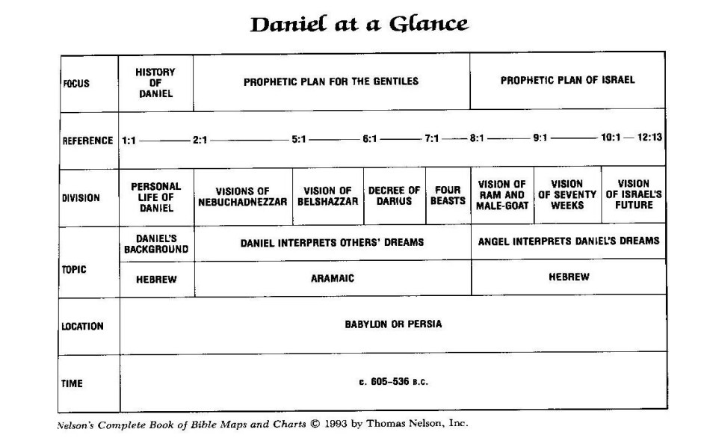
  - The languages in which the book suggests this form. The sections written in Hebrew are for the Jews (Chap. 1, 8-12), while the middle section in Aramaic is written to the nations (Chap. 2-7).
  - At the same time, the middle section is a “chiastic” structure, similar to a palindrome (“able was I ere I saw the Elba”), reading the same forward and backward. In this middle section, then, chapters 2 & 7 are similar (representing 4 kingdoms), chapters 3 & 6 demonstrate God’s power in delivering His servants, and chapters 4 & 5 God’s judgment on proud rulers.
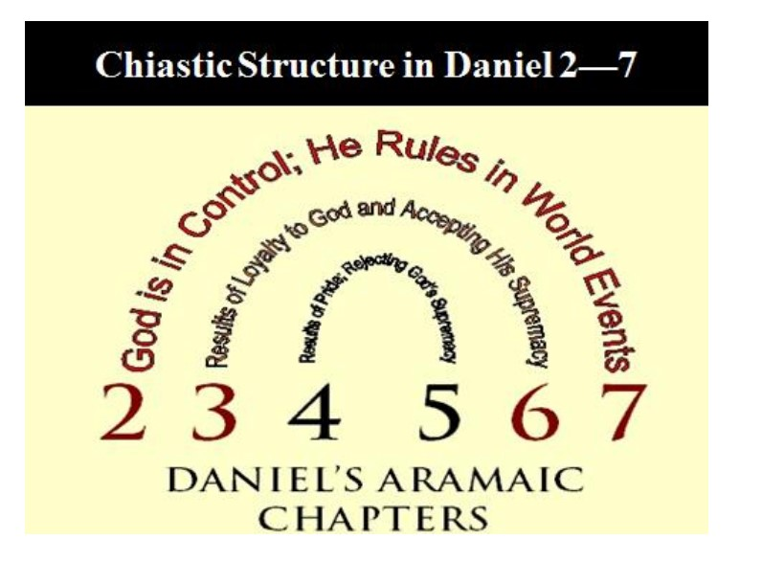
  - Looking at this structure in greater detail, we have:
    - Nebuchadnezzar’s Dream of a Great Statue (chap. 2) [God’s Rule over 4 World Empires]
    - Nebuchadnezzar’s Golden Image (Chap. 3) [Preserving Daniel’s friends, fiery furnace]
    - Nebuchadnezzar’s Dream of the Tree (Chap. 4) [God humbling proud Nebuchadnezzar]
    - Belshazzar’s Feast (Chap. 5) [God judging forgetful Belshazzar’s pride]
    - Darius’ Decree (Chap. 6) [Preserving Daniel in the Lion’s den]
    - Daniel’s dream of the 4 Beasts (Chap. 7) [God’s Rule over 4 World Empires]
  - However, to complicate things, the book can also be delineated in two major divisions – the first, a collection of stories (chaps. 1-6) with a short apocalyptic insertion in chapter 2, and the the visions of Daniel (Chaps. 7-12).
  - In this view, the structure would be History (1:1-6:28) and Prophecy (7:1-12:13)
  - Date and Authorship of Daniel
  - As with a number of aspects of this book, there is controversy over its author and date of authorship. Critical view disallows the detailed prophecy of kingdoms in Daniel, arguing that it must have been written after the events occurred, and therefore Daniel could not have been the sole author. This view negates other Scripture’s prophetic sections as applying here. And discoveries from the Qumn scrolls validate the accuracy of Daniel being the author. From the evidence of the book, the date of authorship is likely near the end of his life, while still in Babylon, somewhere between 536 and 530 BC.
- We could go into much detail describing the kingdoms mentioned and their history, the symbolism of the book, and the relationship to the Tribulation and End Times. Given that this is a survey series, it is more important to discuss the major themes of the book, and so for a detailed analysis of Daniel I refer you to the series on Daniel by Pastor Dykstra some years ago in the Wednesday evening Theology lessons. A link to the notes for the series is here (https://mbcmi.org/old-testament-and-new-testament-bible-survey/). To watch videos of the videos, you can begin here (https://www.youtube.com/watch?v=x2_n1mx9tku). The material below is from the teaching notes.

- Major Themes and Passages of Daniel
1. The Key Theme of the book of Daniel, as we have seen, illustrates that “God has dominion over all the kingdoms of the earth, even in evil days when wicked empires rule the world.” And “the God of Israel is the Sovereign of the Universe.”
  - Daniel 4:34 says, “For His dominion is an everlasting dominion, and His kingdom endures from generation to generation.”
  - God is the One who controls human history. The book illustrates this in clear examples (Nebuchadnezzar, Belshazzar, Darius, etc.). His rule is not merely over Jerusalem and the Israelites. This would provide great comfort and hope to the Jews who were exiled in a foreign land, under pagan and ungodly kings.
  - This provides hope for the future and ultimate restoration of all things to us as well, as we exist as believers under ungodly and pagan rulers, and see the gradual decline of the world to greater and greater sin.

- We see as well, the Pride of Humankind
  - Pride, arrogance, and hubris are evident throughout the book. God consistently condemns these attitudes, and turns them into shame, humiliation, defeat, and death.
  - “Twelve months later, he (King Nebuchadnezzar) was walking on the roof of the royal palace of Babylon. The king reflected and said, ‘Is this not Babylon the great, which I myself have built as a royal residence by the might of my power and for the glory of my majesty?’ While the word was in the king’s mouth, a Voice came from heaven, saying ‘King Nebuchadnezzar, to you it is declared: sovereignty has been removed from you, and you will be driven away from mankind, and you dwelling place will be with the beasts of the field. You will be given grass to eat like cattle, and seven periods of time will pass over you until you recognize that the Most High is ruler over the realm of mankind and bestows it on whomever He wishes.’” (Daniel 4:29-32)
  - “Yet you, his (Nebuchadnezzar’s) son, Belshazzar, have not humbled your heart, even though you knew all this (Nebuchadnezzar’s banishment to be like a beast of the field), but you have exalted yourself against the Lord of heaven; . . . But the God in whose had are your life-breath and all your ways, you have not glorified.” (Chap. 5:22-23) “That same night Belshazzar the Chaldean king was slain.” (Chap. 5:30)
  - Later examples in chapters 7-12 continue the theme of arrogance and self-sufficiency of earthly rulers, climaxing in the “little horn with the big mouth” (7:8, 25; 8:9), commonly recognized to be Antiochus IV Epiphanes (175-164 BC). He is considered to be a precursor of the Antichrist of the End Times.
  - This should teach us to recognize God’s sovereign rule and keep us from arrogance and pride, and to remember to give glory to Him alone and to remember that we are His children. We must remember that it was pride that caused Satan to be cast from heaven, and not allow us to sin similarly.

3. We see the establishment of God’s Kingdom on Earth
  - “More than any other book in the OT, Daniel revealed the connection between God’s universal kingdom and the mediatorial earthly kingdom, and the course of Gentile kingdoms in history before God’s kingdom is established on earth. . . . Human government is the primary means this rule is carried out. Yet because mand and human governments are fallen and sinful they are antagonistic to God’s will and do not successfully carry out the dominion mandate. As these governments function, they are still under God’s sovereignty. Yet the time will come when God’s kingdom will replace rebellious human governments and God’s kingdom will be established on earth. Thus, the kingdom of God, which replaces rebellious human kingdoms, is the central theme of Daniel.”
  - Daniel illustrates the human kingdoms and the establishment of His ultimate kingdom in these chapters:
    - Chapter 2 tells of the Kingdom to come, after 4 great world kingdoms. The “stone cut without hands” (referring to Christ, as the cornerstone of His kingdom?) strikes the feet of the statue of the four great kingdoms, and becomes “a great mountain and fills the whole earth” (2:34-35). This kingdom will “crush and put an end to all these kingdoms” and “will itself endure forever (2:44)”.
    - The four Gentile kingdoms of the statue in chapter 2 are described in chapter 7 as the four great beasts. After this, there will finally come the Antichrist, who will torment God’s people for 3 ½ years, at which point “his dominion will be taken away, annihilated and destroyed forever” (7:26). Then, the kingdom of God will come and the saints will take “possession of the kingdom (7:22), as His people are vindicated and rewarded.
    - The arrival of God’s kingdom is described in 3 events, in chapter 12. First, the people of Israel will suffer great distress (12:1a). Then, they will be rescued (12:1b). Finally, there will be a resurrection (12:2) and the kingdom of God will come to earth.

4. We learn of the coming Messiah
  - He is the one who conquers God’s earthly enemies and ushers in His earthly kingdom. He is the “Son of Man”, the Messiah. Daniel shows Him to be not only the One who would redeem Israel, but would also be the King who would rule over God’s earthly kingdom when it is established.
  - He is the One who overcomes the “little horn” (7:13), a terrible world dictator who is the embodiment of the Antichrist (7:8). He is the final King in the line of David.

5. Daniel prophecies Israel’s future deliverance and blessings
  - This will occur in the Millennial reign, where Abraham’s descendants will finally occupy the land promised to them by God.
  - They will be disciplined for disobedience, and brought to repentance and restoration.
  - They will finally recognize their Messiah.

6. Implicit throughout the book also, is the lesson that God uses faithful men as He brings about His purposes. They are also examples to God’s people of how to remain focused on the hope we have for deliverance, restoration, and ultimately being with Him for all eternity, as we go through trials, suffering, loss, and pain. These men teach us to remain constant in our devotion to the Lord, no matter the cost, no matter the outcome. Shadrach, Meshech and Abed-nego believed that God would deliver them in the fiery furnace, but that “even if He does not, let it be known to you, O king, that we are not going to serve your gods or worship the golden image you have set up.” (3:18). And Daniel, when he knew that Darius had signed a proclamation at the instigation of his jealous peers, that no one could pray to any god or man for 30 days except for the king, “he entered his house (now in his roof chamber he had windows that open toward Jerusalem), and he continued kneeling on his knees 3 times a day, giving thanks before God, as he had been doing previously.” (6:10). When Darius reluctantly had him put in the Lion’s den, the Lord stopped the mouths of the lions, and Daniel was spared.

There is much that is deep and somewhat obscure as we read the book of Daniel, as we have seen. But there are also lessons we can take away that we can apply daily, as we go through the life to which God has called us, and sovereignly ordained for us.

Final thoughts on Joel and daniel together

- Taken together, Joel and Daniel reinforce the unity of Scripture. Both provide prophetic and eschatological perspective on the future certainty that God, in His sovereignty, will restore all things under His rule at the end of time; that the world will be brought back to His kingdom, out of the sin that invaded it at the Fall, and that He will reign supreme again, and Man will be restored to a right relation with Him in righteousness.
- I liked researching both of these books for just that reason – that they complement each other, and that despite the difficulty of understanding completely everything contained in them (just as with other aspects of Scripture), they reveal the God who works all things for His good pleasure and purposes, and ultimately for the good of those who love Him and whom He has called.
- We also see God’s covenants to Abraham, Isaac and Jacob and their descendants – and ultimately we who love Him – at work in promising them a land and material blessings to them if they obeyed the Law (Gen. 12,13,15, 17, 26, 28, 35, 1 Chron. 16, 2 Chron. 20), discipline and dispersion if they disobeyed continually (Dt. 28), but ultimately restoration and regathering, together with a circumcised heart (not merely physical circumcision) (Dt. 4, 30).

A Commentary on the Book of the Twelve, Michael B. Shepherd, page 16
Moody Bible Commentary, Joel, page 1332
Moody Bible Commentary, Joel, pg. 1334
Ibid, pg. 1334
Ibid, pg. 1336
Commentary on the Book of Twelve, Michael B. Shepherd, pg. 147
Daniel: An Introduction and Commentary, Joyce Baldwin, pg. 66
An Introduction to the Old Testament Prophetic Books, Updated Version, C. Hassell Bullock, pg. 354
Moody Bible Commentary, Daniel Introduction, pg. 1281
Ibid
A Theology of Ezekiel and Daniel, Eugene Merrill, pg. 388
Vlach 2017, pg 207
Moody Bible Commentary, Daniel Introduction, pg. 1280

