God’s Provision of Defense, Standing Firm in the Battle

Ephesians 6:14-16

Ephesians 6-14-16 (NASB95)

14 Stand firm therefore, HAVING GIRDED YOUR LOINS WITH TRUTH, and HAVING PUT ON THE BREASTPLATE OF RIGHTEOUSNESS,

15 and having shod YOUR FEET WITH THE PREPARATION OF THE GOSPEL OF PEACE;

16 in addition to all, taking up the shield of faith with which you will be able to extinguish all the flaming arrows of the evil one.

Roman Soldier Example:

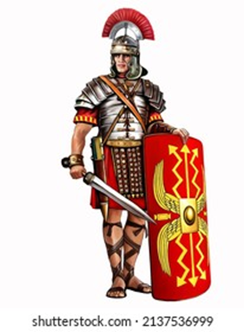

Other examples in the Bible

Psalm 7:10, Psalm 18:1-2, Isaiah 59:17

v 14: Stand firm therefore, HAVING GIRDED YOUR LOINS WITH TRUTH, and HAVING PUT ON THE BREASTPLATE OF RIGHTEOUSNESS,

* “stand firm” – Matt 26:29-31, Matt 26:69-75, 1 Peter 5:9, 1 Cor. 15:58, Phil. 1:27, 1 Cor. 16:13
* “Gird your loins”- PS 1:2, Eph. 4:26, Phil. 4:6, Rom. 12:10
* “Truth”- PS 119:151, PS 119:160, John 17:17
* “Breastplate of Righteousness”- Is. 59:17, Eph. 4:22-6:9

(These are my paraphrases of Eph. 4:22-6:9, not an exact verse by verse representation.)

1. Lay aside the old self, address and change patterns of sin and wrong thinking.
2. Read/study/pray so that your mind would be refreshed on God’s words and not the world’s.
3. Be imitators of God, doing the things God calls you to- confession of sin, forgiveness of others, loving one another, speaking truth to one another.
4. Work for what you need, don’t steal or take what is not rightfully yours
5. Keep harmony and peace within the body of believers.
6. Don’t hold on to bitterness or anger. Seek forgiveness or forgive even when reconciliation is not possible. Don’t let it go unresolved.
7. Walk in the spirit of love, showing Christ’s love to one another and sacrificing your wants/desires for others.
8. Don’t be greedy or loving of worldly possessions. Keep yourself sexually pure.
9. Words should be from love, affirming one another.
10. Confess and battle idolatry.
11. Examine the words of others for truthfulness and faithfulness. Don’t be deceived.
12. Examine where you spend your time and effort. If activities are unfruitful, don’t do them.
13. Do not get drunk/high/or otherwise alter your ability to think clearly. Be filled with the joy of God instead.
14. Encourage one another, reminding one another about who God is and worshiping Him.
15. Give thanks to God in all situations and for all things.
16. Be willing to submit to one another, listen to correction.
17. Wives submit to your husbands.
18. Husbands love your wife completely and sacrificially.
19. Children should obey their parents.
20. Parents should not do things to anger or hurt their children.
21. You should always do what God calls you to as God will reward whether it is recognized in your life or not.

v 15 and having shod YOUR FEET WITH THE PREPARATION OF THE GOSPEL OF PEACE;

* Matt. 7:24-27, Is. 52:7, Rom. 10:15, Rom. 8:1-2, Rom 8:37-39

v 16 in addition to all, taking up the shield of faith with which you will be able to extinguish all the flaming arrows of the evil one.

* Eph. 4:14-15, 4:25, 5:19, 1 Peter 1:13

# Bibliography

(SexualDiversity.org), S. D. (2023, May 22). *SexualDiversity.org/edu/1111.php How Many Genders Are there? Gender Identity List.* Retrieved from www.sexualdiversity.org: https://www.sexualdiversity.org/edu/1111.php

Henry, M. (2203, July 6). *commentaries Matthew Henry Complete 1 Corinthians 16.* Retrieved from www.biblestuddytools.com: https://www.biblestudytools.com/commentaries/matthew-henry-complete/1-corinthians/16.html

MacArthur, J. (20098, Nov. 16). *Sermons Library 90-366.* Retrieved from www.gracetoyou.org: https://www.gty.org/library/sermons-library/90-366/the-armor-of-god-the-shoes-of-the-gospel-of-peace-and-the-sheild-of-faith